* Simple Connection between two PCs (no additional device) 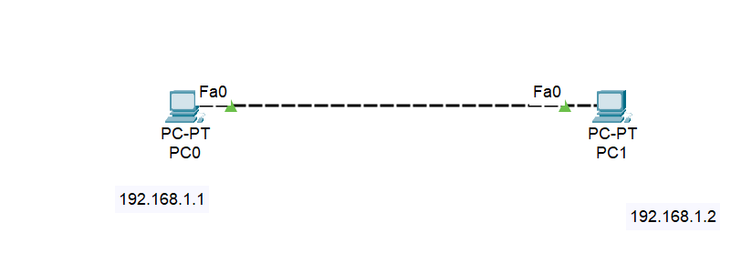
* HUB Practical
* Please show how to assign IP address in PC in packet tracer
* And show the broadcasting nature of HUB.